# Einstellungen Octopus

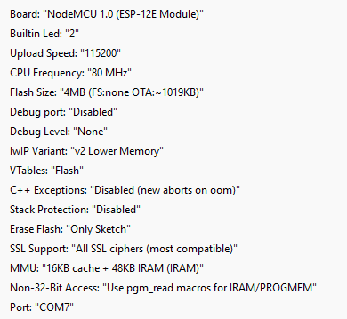

# iAQ Farbtabelle

|  |  |  |  |
| --- | --- | --- | --- |
|  | R | G | B |
| 0 | 228 | 2 |
| 126 | 208 | 20 |
| 255 | 252 | 5 |
| 255 | 126 | 0 |
| 255 | 19 | 0 |
| 164 | 32 | 64 |
| 102 | 51 | 0 |